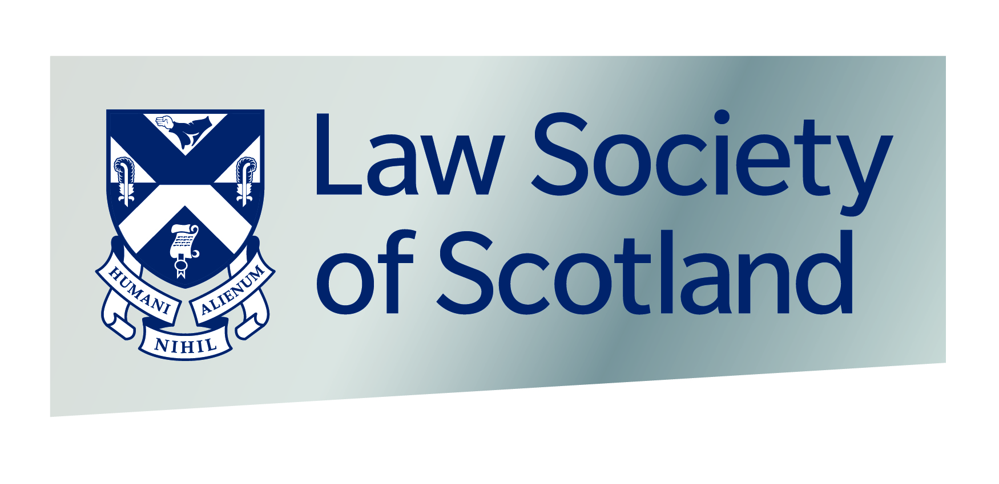

Nomination for Honorary Membership of the Law Society of Scotland in 2019 – deadline for submission is 29 March 2019
PLEASE TYPE OR PRINT WHEN COMPLETING APPLICATION FORM
1. Name and address of solicitor nominated for Honorary membership of the Law Society of Scotland
Full Name
Firm (if applicable)
Home or Business address (if known)
Telephone No:
(if known)
Email: (if known)
2. Name and address of person proposing the nomination
Full Name
Firm (if applicable)
Home or Business address
Telephone No:

3. The single criterion for the nomination of Honorary Membership in 2019 is “for outstanding service for the public good by a Scottish solicitor”. Please provide your reasons as to how your nominee has achieved this “mark” (Maximum 500 words)
Signature of proposer
Date

